Instructions for using lfsImageTool:
- Extract the lfsImageTool tool under Linux and modify the permission using chmod 777 lfsImageTool -R.
- Execute the make command to generate the mount directory. This directory is the mapping of customer_fs.bin.
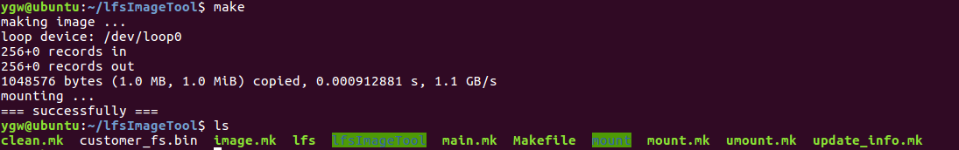
- After entering the mount directory, copy '8K.wav' to the mount directory.
- Replace the customer_fs.bin in the firmware package with the modified one from the mount directory. After burning the firmware, the audio file will be stored in the user partition.
- Change the name of "8K.wav" in the example to "U:/8K.wav".

